EXPERIMENT – 9
LOGISTIC REGRESSION
Aim:
To perform model classification using Logistic Regression

Procedure:
1. Upload the given dataset
2. Import all the necessities
3. Read and make it as Data Frame.
4. Through sklearn and train the model
5. Test the model

Program:
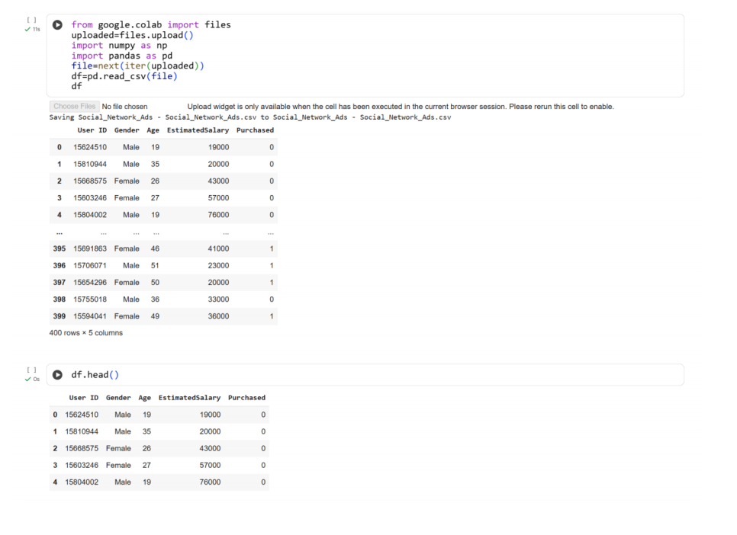
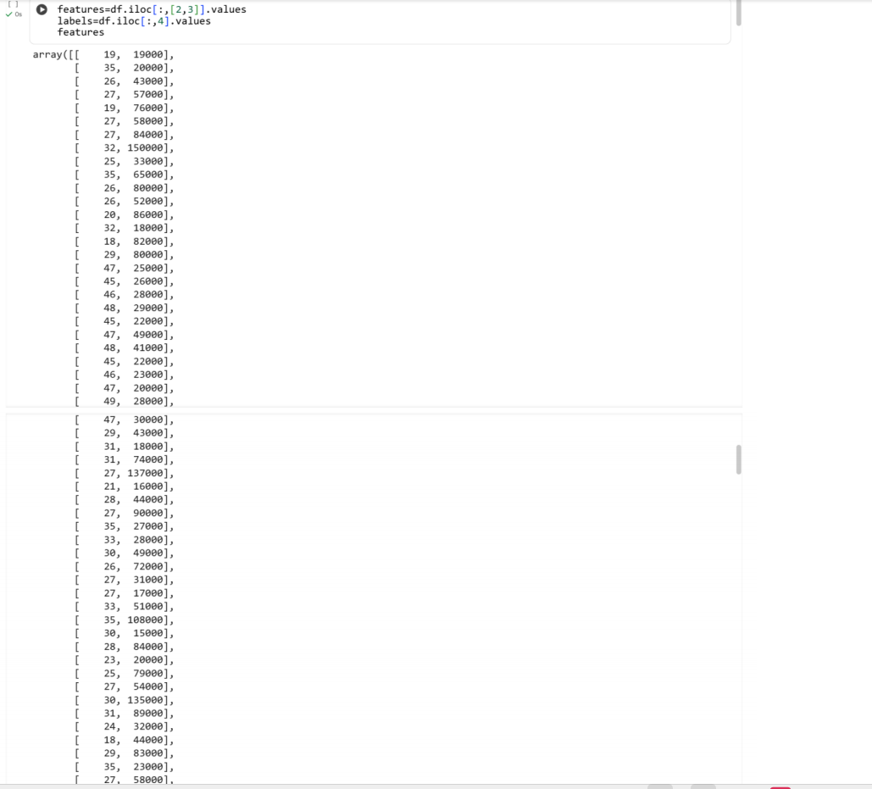
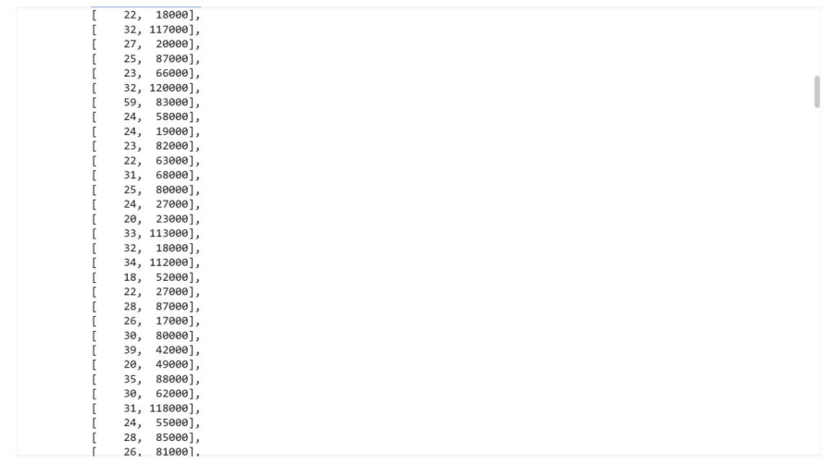
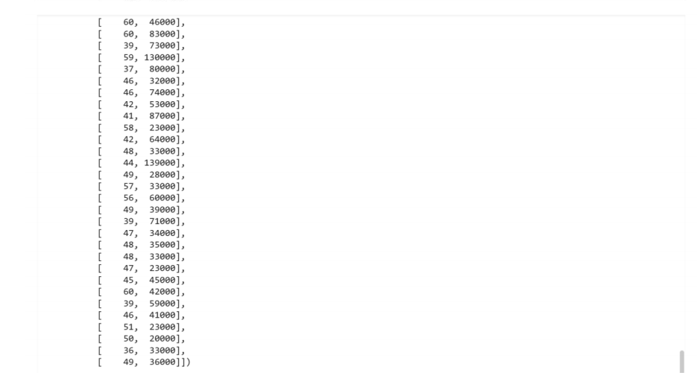
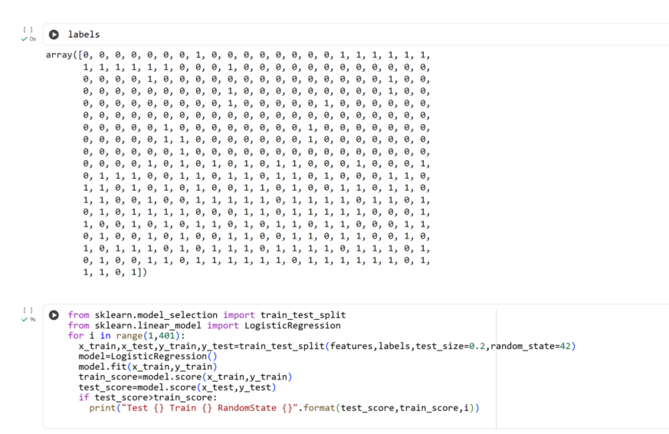
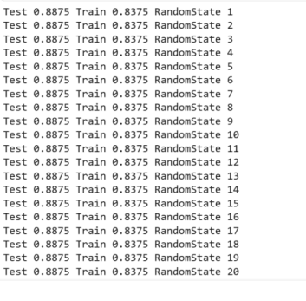
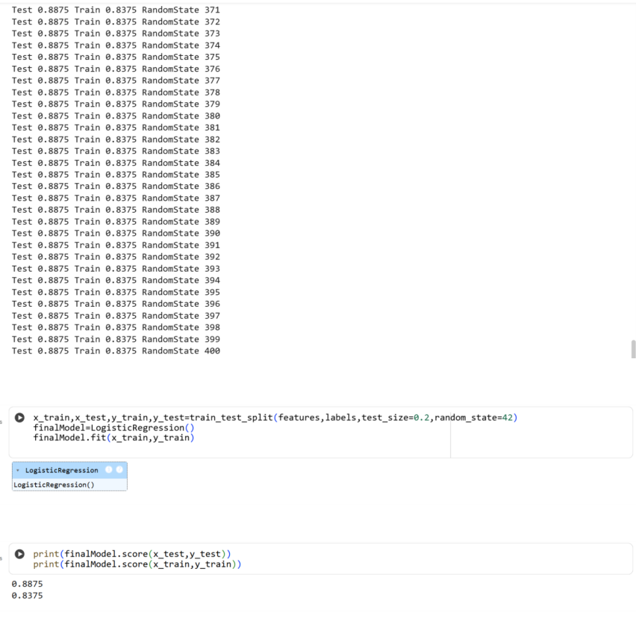
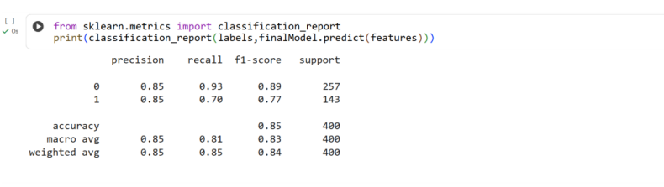
Result:
Thus the python program to perform the model classification using Logistic Regression is executed and verified successfully

